FACULTY PROFILE

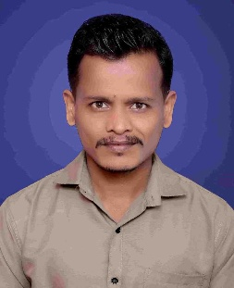

Name : Dr. Wagh Maruti Sambhaji

Qualification : M.Com, NET, SET, Ph.D

Department : Commerce

Designation : Assistant Professor

Email :marutiwagh99@gmail.com

Teaching Experience : UG. 10 Years
ACADEMIC CONTRIBUTIONS

Books Published : 01
Research Papers : 14
Conference Attended : 15
Guest Lectures Delivered : 03
Research Area : Marketing
Research Work:
- Completed Ph. D on “A Study of Agriculture Produce Market Committees’ role in Livestock Trading with special reference to Satara District” at Department of Commerce & Management, Shivaji University Kolhapur.” On 30th September, 2025
- Ongoing miner research project sponsored by Arts and Commerce College, Pusegaon
Achievements:
- Received grant from Maharashtra state government for book publication
- Second in National Leven Gandhi Sanskar Exam in Satara district

